2016-17 WORK PLAN ACTIVITIES TO ADDRESS FOCUS AREAS OF INDUSTRY SECTOR
STRATEGY, EDUCATION, INNOVATION, EFFICIENCY & SUPPLY AND DEMAND

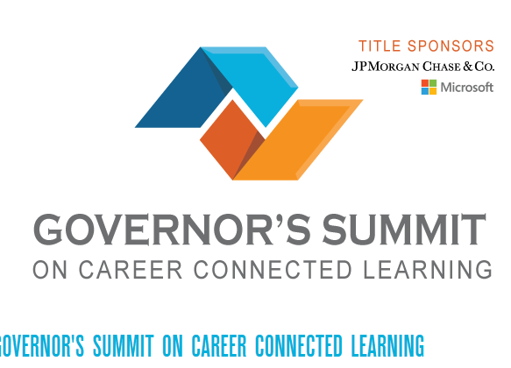
Anita Janus, briefed Center staff about what she learned from her participation in the Governor’s Career Connected Learning Summit which was held on May 31. She joined a statewide webinar where industry, policy, and education leaders all across the state discussed the work that is being done to share best practices and policies to increase and strengthen career-related opportunities in high demand jobs for Washington’s youth. The Governor’s Summit on Career Connected Learning was heard at several sites across the state. Center staff participated in both western and eastern WA venues. Presenters focused on the need for Washington to ensure that young people receive an education that prepares them to take part in our economy and real world by having access to hands-on career connected learning opportunities.
The Governor’s summit goals aligns with the work that the Center has been doing for several years including the establishment of the “Work Experience Market Place” which utilizes direct employer engagement activities to dramatically increase job placements through the establishment of a sustainable internship brokering program. The Center will continue to expand and enhance its “career connected learning” activities with K-12 dual degree opportunities and to establish apprenticeship and pre-apprenticeship programs in our public safety, security/cybersecurity and emergency management pathways.

The Center staff met with State Board staff and Pierce and Edmonds Colleges Dean and faculty of the joint Occupational Safety and Health (OSH) Program to discuss the current apprenticeship pilot and discuss how the apprenticeship model could be applied to additional careers in the field including the Insurance Industry. Meetings will continue in June with Insurance Industry representatives to discuss the opportunity of establishing an apprenticeship program for the industry.

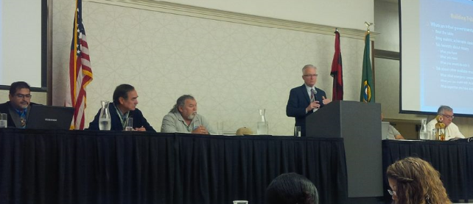
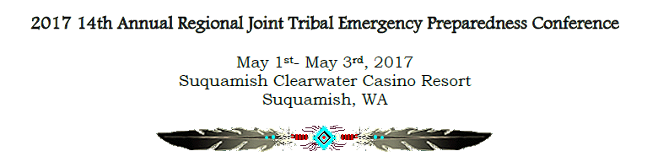
This year’s theme was “Emergency Preparedness: Stronger Together.” The agenda focused on ways to improve and enhance inter-agency and cross-jurisdictional collaboration across all disciplines with all partners. Attendees included government leaders, first responders, public health partners, emergency managers, veterans and military partners, casino security departments and corporate partners and vendors. The Center’s Director, Linda Crerar, provided information to attendees on Public Safety, Security and Emergency Management educational pathway programs available within the SBCTC system and she also provided an overview the work being done by the National Tribal Emergency Management Council’s Education Committee of which she is a member to establish a NTEMC Certification for tribal governments. The work of this Committee will be ongoing throughout 2017.

The Center was provide an exhibitor booth at no cost thanks to our Board Member Lynda Zambrano the Director for the Tribal Emergency Management Council. The Center was able to provide opportunities for participants to speak one-on-one with our career navigator representatives the broad diversity of education and training programs available at our community/technical colleges across the state. Many people we talked with were unaware of the diversity of career training and education opportunities available within the public college system and were very appreciative of our efforts to provide them personal orientation sessions to address their specific questions.

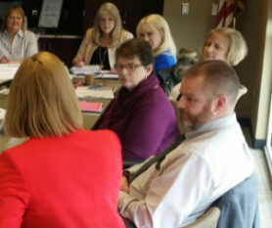
May 16, 2017 HSEM Center Board Meeting:
Review Center Receives Final CTC Site Review Report
On April 24, 2017, received the March 29 Site Review Report from Nancy Dick, SBCTC Workforce Education Director. Chair, Chris Johnson, facilitated the discussion which included a review of the Center’s commendations and recommendations. Chris said that this year’s SBCTC Site Review was more conversational than the one two years ago. Chris and Curry Mayer focused their separate discussion with the Reviewers around the topic of how the Center is expanding its involvement in career pathways and internships. Both of them provided insight to the reviewers on how they would like to see the Center evolve over the next several year. They made sure to explain how HSEM careers tie in with not only the public sector, but private sector as well. Chris shared how his organization has made a commitment to host internships for a variety of CTC careers including HSEM and Occupation Health and Safety. Linda shared with the Advisory Board how the SBCTC liked their matrix management approach. The SBCTC said that the CoE-HSEM could be a model to other Centers.
The Center would like to provide opportunities to HSEM students and graduates, along with the other All-Hazards EM educational/career pathways the chance to participate in more networking events with employers. The Center will also be reaching out the Skills Centers across the state to help create more pathways for students interested in the All-Hazards EM field. Previously, the Center was told by the SBCTC to not work with the Skills Centers, because it was not deemed a priority but with the new emphasis on “career connected learning” the Centers are being encouraged by the State Board to facilitate discussions and actions that support a high school “Running Start” (dual credit) approach to obtaining a high school diploma and AA degree simultaneously. This was wholehearted supported by Board Members. Member believe there needs to be a change in the mindset of the college system to work very collaboratively with our states high schools and skills centers.
The Center has successfully accomplished its 2016-17 work plan objectives and the 2017-18 plan will continue to focus on the priority elements the Advisory Board believes are critical to student career success (completing degrees and gaining employment). The staff will proceed to draft up its 2017-18 work plan with the following core themes:
- Career Connected Learning/Pathways: Engaging our colleges and their communities and employers to engage in employers to commit to support career-connected learning and pathways to jobs in their industries.
- Expanding the Work Experience Market Place to grow intern and apprenticeships and volunteers opportunities with our career pathway employers.
- Continue to effect system improve and innovations to improve processes, accountability and increase graduation and employment rates.

Collaborating Colleges Model – Applied to Peninsula’s Cybersecurity AA Degree
The Center working with Peninsula College and their fully online Cybersecurity & Computer Forensics Program continues to replicate the Pierce College “Collaborating Colleges” model. Peninsula College was the first college to join Pierce’s HSEM online AA degree program as a collaborating college. Pierce indicated an interest to collaborate with Peninsula to offer its Cybersecurity degree. The colleges have agreed share the program and will follow the model outlined in the Collaborating College Guide to complete an MOU.
Navy Veterans Hiring/Education Event
Center staff attending this large veterans hiring event on May 24, at the Doubletree Hotel at SeaTac. Staff met with employers and veterans providing information about the SBCTC career pathway programs including the new HSEM BAS degree at Pierce College and the AA and BAS Cybersecurity degrees now available statewide in the CTC system.

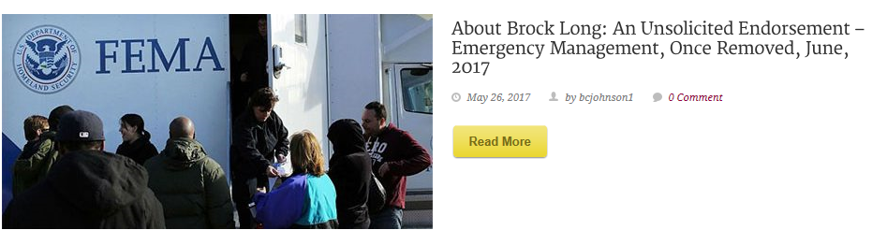The May Blog post from Jim Mullen, one of our Center’s Senior Fellows, discusses the nomination of Brock Long to be the new FEMA Director. Brock has been a friend for the Center ever since his involvement and key note presentation at our Center’s 10th Anniversary Summit in 2015. We all pleased to see a career professional being nominated for this critically important job. Read Jim’s post and join the discussion on these very important issues. http://wp.pierce.ctc.edu/blog/hsemcoe/hot-topics/
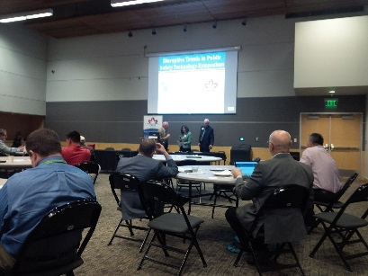
Disrupting Trends in Public Safety Technology Symposium
Center staff attended the PNWER Public Safety Technology Symposium on May 23, at the McGavick Conference Center, Clover Park Technical College. The Symposium discussed technology innovations including artificial intelligence and UAV (drone) and automation such as self-driving vehicles that will revolutionize how we will accomplish our first responder missions. The Center spoke about the need to offer internship and volunteer opportunities for students in our colleges and universities to gain work experience so become viable candidates for these new job opportunities.

Up Coming Events

12th Annual Energy and Construction Best Practices Summit June 1-2, 2017
Centralia College - Solutions for a Multi-Generational Workforce
Join the Centers in learning about how you can navigate the challenges of today’s workforce and learning environments from Dr. Mark Taylor an internationally recognized speaker on multigenerational transformations. Also join Governor Jay Insee and Chris Reykdah, Superintendent of Public Instructions to learn about their efforts and initiatives to build diverse pathways helping our students connect with employers throughout the state.

Pacific Northwest Disaster Resilience Symposium
When: July 24-25, 2017
Where: Portland Marriott Downtown Waterfront
1401 SW Naito Pkwy, Portland, OR 97201
Cost: $195
The Pacific Northwest Disaster Resilience Symposium is a two-day event hosted by the Center for Regional Disaster Resilience and developed to bring together leaders and decision makers from throughout the region to address common issues, examine solutions, and promote information sharing. The Symposium will be take place on July 24-25, 2017. It will be embedded within the Pacific Northwest Economic Region’s Annual Summit in Portland, Oregon, from July 23-27. Embedding the Disaster Resilience Symposium within the larger PNWER Summit will provide attendees with the opportunity to interact face-to-face with elected officials and legislators and increase awareness for important disaster resilience issues.
Registration

2017 COE Schedule of Events

June-July Women in Leadership Networking Event– Location, Date, and Time TBA
June 14 HSEM-Center Advisory Board Meeting
July PNWER – Public Private Partnership Workshop at Portland Conference
August TEEX – Higher Education EM Planning 3-day training at Cascadia College
September WSEMA Conference – Location and Dates TBA
September 28 Energy and Technology Transportation Infrastructure Workshop, Portland, Sponsored by Center for Disaster Resilience
October Women in Leadership Forum – Peninsula College 9:00 a.m. to 3:30 p.m.
October Advisory Board Meeting – Location TBA; 12:00 p.m. to 4:00 p.m.

