***2016-17 WORK PLAN ACTIVITIES TO ADDRESS FOCUS AREAS OF INDUSTRY SECTOR***

***STRATEGY, EDUCATION, INNOVATION, EFFICIENCY & SUPPLY AND DEMAND***

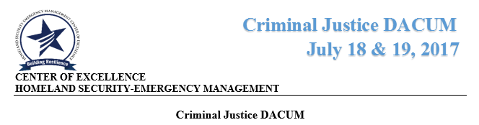

On July 18 & 19, 2017, the Center hosted the Community and Technical College ***Criminal Justice (CJ) DACUM*** at Big Bend Community College in Moses Lake, Washington. The DACUM brought together CJ Program Coordinators and faculty, college Deans, and employers from around the state to continue the discussion from its March meeting on establishing a statewide agreed upon CJ basic core curriculum for all our programs to utilize. Tony Anderman who is an expert in the field of law and justice facilitated the CJ DACUM. He guided participants helping them to address the gaps and needs CJ students need in order to be successful in the field.

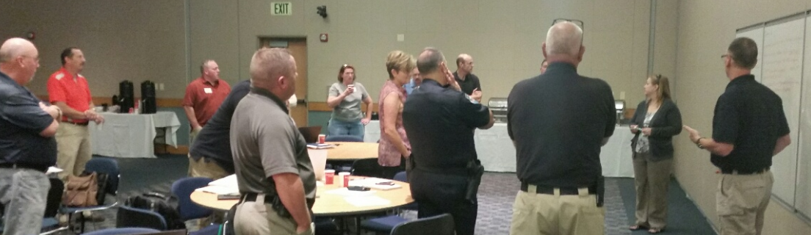

*Coordinators from around the state, faculty and employers from Juvenile Court/Youth Services, Police Chiefs and Sheriffs, and other law enforcement officials discussed and identified curriculum.*

During the first day of the meeting participants discussed the current state of the CJ training/education system in Washington State. On the second day the group was focused on the needed curriculum. Participants were asked “What does a Basic Law Enforcement Officer look like after they complete their education – What are the KSAs (Knowledge, Skills, and Abilities)?” A final briefing document summarizing the meeting has been completed and the draft DACUM summary submitted to the CJ working group. These documents will be shared with all members of the CJ working group, CTC Deans and other education partners. Both reports will be available on the Center’s website. The CJ Programs Work Group will next meet in Spokane, November 7th and 8th, to review the priority core curriculum identified and discuss the DACUM recommendations. The meeting will be in conjunction with the new State Association’s (see below) conference.

The newly formed ***Washington State Association of Public Safety Officers and Educators*** (WSAPSOE) help its first Board Meeting in Moses Lake during CJ Programs meeting. The goal of the Association is to bring together public safety professionals and educators to collaborate, exchange ideas and increase public safety through sharing best practices. The Association will also be addressing the development of State and National Content Certifications Programs. Dr. Ryann Leonard the Coordinator and faculty for the Criminal Justice Program in at Big Bend and Linda Crerar, Director for HSEM Center of Excellence we invited to join the Board. The Associations kick off conference will be held November 7th and 8th at the Spokane Sheriff’s Office Training Center in conjunction with the CJ Programs Working Group. Currently the Association is working on establishing their website and providing and developing their membership outreach campaign. For additional information contact Steve Lettic at [slettic@gmail.com](mailto:slettic@gmail.com).

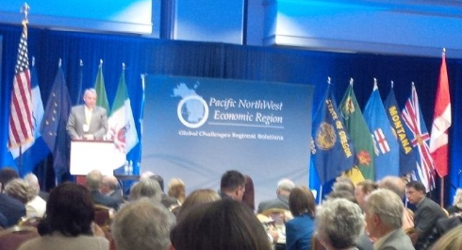**Pacific Northwest Disaster Resilience Symposium**  
  
The Center Director attended the Pacific Northwest Disaster Resilience Symposium in Portland July 24-25. This two-day event hosted by the Center for Regional Disaster Resilience and brings together leaders and decision makers from throughout the region to address common issues, examine solutions, and promote information sharing. Wendy Freitag, the Center’s Communication and Outreach Specialist worked with Eric Holdeman the CRDR Director to put together the Public-Private Partnerships Panel on Resilience. The panel explored how high-impact, sustainable public-private partnerships (P3) provide crucial frameworks to address complex emergency management goals. Another session Facilitated by Pat Massey, Regional Director for DHS Office of Infrastructure Protection and former COE HSEM Board Member explored the transportation and energy sectors and their important for regional recovery. James Maltby, Corporate Director of HSSE, Lynden Transport and new COE HSEM Advisory Board Member spoke about how the transportation sector is preparing for recovery. The Symposium was embedded within the larger PNWER Summit will provide attendees with the opportunity to interact face-to-face with elected officials and legislators and increase awareness for important disaster resilience issues.

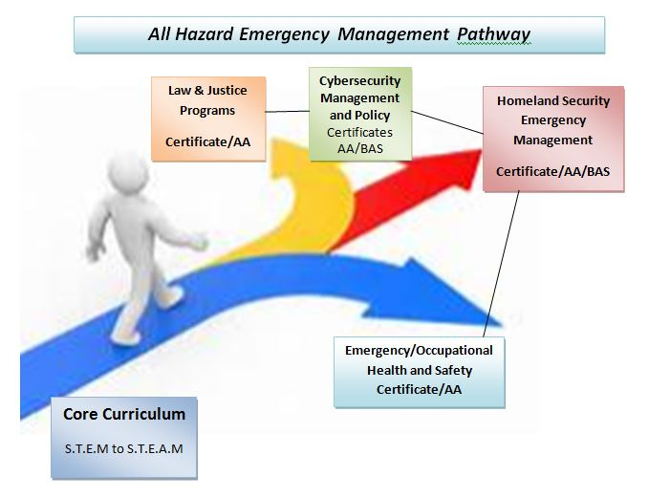

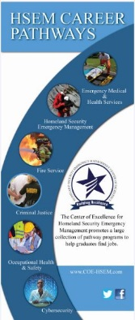***All Hazard Emergency Management Career Pathway***

The Center staff have been working throughout the spring and summer to develop new marketing materials and visual graphics that can be utilized to inform people who are interested in public safety, security/cybersecurity and emergency management careers to look at the excellent programs and training available in the Community and Technical College system. The Center’s Graphic Designer, Jasmine May, has created a new brochure and a quarter card which displays all six of our HSEM pathways and she is currently working with Linda on taking the “career pathways” representation above and populating it with a “roadmap” that charts classes that are in common among the six career degrees and certificates so potential students see that their first steps into the HSEM career field courses establish a solid knowledge base for them to choose pathways into all of the six career fields that are offered in our SBCTC programs across the state. She is also working with Shane Moore our Employer Engagement Outreach Specialist to design a brochure which will inform employers and students about our opportunities to complete internships and apprenticeships in their chosen career field in public, private and non-profit organizations.

**Annual Work Plan 2017-18 Submitted to the State Board on July 31**

Every year the Center staff working with our Board and stakeholders reviews the Center’s current work and holds a strategic planning session to discuss and identify plan activities for the coming year.   The State of WA budget year is July 1 – June 30.  The work plan activities are addition to all of our **basic functions** which are proscribed by the State Board and   include:

* Convene, problem solve & disseminate industry specific solutions.
* Provide & solicit updates from stakeholders.
* Provide maximum efficiency and leverage resources to support operations/initiatives.
* Effective broker for all colleges.
* Maintain an effective website.

The final HSEM FY 2017-18 Work Plan is available on the Center’s website along with each quarter’s work plan reports for the past two year.  The Center’s total budget for this year is $203,157. A budget breakout of salaries and expenses is provided to the State Board along with the plan.

Activity #1 – Supply Chain management Curriculum Collaboration – “Technology and Supply Chain Management” Forum – Will be our 3rd event in the past three years and the focus will be on technology.

Activity #2 - Career Connected Pathways – Center will continue to expand and enhance its “career connected learning” activities with K-12 including dual degree/Running Start, internship expansion, and pre-apprenticeship/apprenticeship opportunities.

Expand apprenticeship pilot model partnering with Amazon around Occupational Health and Safety and development of an Insurance Industry apprenticeship program based on the current OSH pilot being sponsored by Edmonds College.

Activity #3 – Public Safety/Security Program Assessment/Enhancement –  continue to work with the 19 CJ Programs and employers to identify the core strengths (KSAs) through a DACUM, develop recommendations/proposal for adopting common core curriculum/numbering, and identifying more effective efficient degree attainment system.

Activity #4 – Women in Leadership Forum – ongoing women leadership development activities including annual Forum.  This year’s Forum starts second stage in establishing an on-line mentorship program which will be referred to “Leadership Circles”.  Periodic networking events will be held. This will be the Center’s third event in the past three years.

**UPCOMING EVENTS**

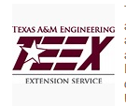**TEEX Training August 15-17 at Cascadia College**

The COE and Cascadia College will be hosting 50 SBCTC college executives and security, safety and emergency management staff at the upcoming Emergency Management Preparedness and Planning course of Education Institution. There is no cost for this 3 day training event which is provided to the state by a DHS training. This is the second TEEX event brought to our CTC system by the Center this year. A similar training for Allied Health Professionals and organizations was hosted with the Allied Health COE at Yakima Valley College in the spring.

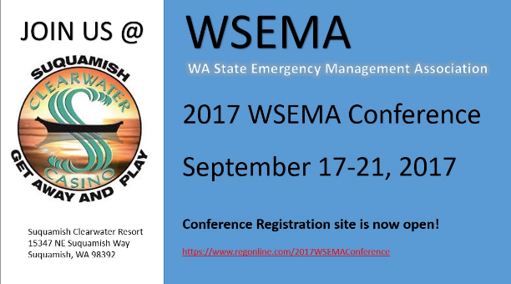

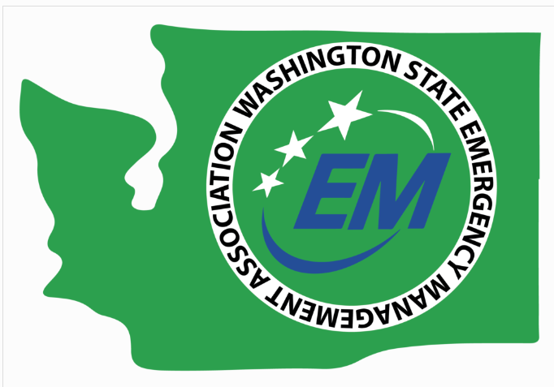

The Center will have an information booth at the upcoming WSEMA annual conference September 17-21. The Center working with our career pathways programs at our college has distributed information about the opportunity for CTC students to join the Association at a reduced membership **Student Members $40.00** and apply for the Joe Aggeraard Scholarship.

**Those interested in applying for the scholarship need to complete this form:**[**Joel Aggergaard Scholarship Application**](http://www.wsema.com/wp-content/uploads/Joel-Aggergaard-Scholarship-Application.docx)**.**

**2017 COE Schedule of Events**

August TEEX – Higher Education EM Planning 3-day training at Cascadia College

September WSEMA Conference – Location and Dates TBA

September 28 Energy and Technology Transportation Infrastructure Workshop, Portland, Sponsored by Center for Disaster Resilience

October Women in Leadership Forum – Peninsula College 9:00 a.m. to 3:30 p.m.

October Advisory Board Meeting – Location TBA; 12:00 p.m. to 4:00 p.m.