***2016-17 WORK PLAN ACTIVITIES TO ADDRESS FOCUS AREAS OF INDUSTRY SECTOR***

***STRATEGY, EDUCATION, INNOVATION, EFFICIENCY & SUPPLY AND DEMAND***

cid:image003.jpg@01D2815C.3DD7E8A0

**Criminal Justice Program**

**Work Group Update**



**CJ Work Group Meeting will be held November 7 & 8, in Spokane in conjunction new Public Safety Officers and Educations Association.**

CJ Programs Work Group’s Strategic Planning Sub-Committee met August 10, at Highline College. The Committee reviewed the information gathered at the July 17-18, DACUM meeting at Big Bend College and developed a strategic plan to implement the recommendations and actions identified at the July meeting. The Planning Sub-Committee is Co-Chaired by Steve Lettic (Highline College) and Ryann Leonard (Big Bend CC). Tony Anderman is a consultant who completed the DACUM report at the July meeting served as an advisor and facilitator for the Planning Committee.

One of the primary focuses for the CJ group is there should be a set of standards and assessments for all of the 20 Criminal Justice programs in Washington State’s 34 Community and Technical Colleges. CJ program process is the core curriculum will lead to the idea of core competencies. Both are intertwined (writing, critical thinking, and KSAs). A core foundation will help set up the next move towards program strengthening.

The resulting draft strategic plan, and the Planning Committee and July 17-18 meeting summaries will be distributed to all of the Criminal Justice, Corrections and affiliated programs and Deans by August 15, along with a short video and message created by Ryann Leonard to update all of the CJ Program Managers and faculty on what has been accomplished since the CJ Work Groups first meeting in March.

The video and “Welcome Back” email from Ryann Leonard is below and we would suggest that you take a few minutes to observe her video and summary of our CJ Programs’ work over the past few months.

***CJ Faculty,***

***Welcome back from your Summer time. We wanted to update you on what the CJ Faculty have been working on and the status of our work that you may have been a part of. I have created a short video.***

[***https://bigbend.hosted.panopto.com/Panopto/Pages/Embed.aspx?id=47c04e42-fc65-4702-b20b-ae9a32927131&v=1***](https://bigbend.hosted.panopto.com/Panopto/Pages/Embed.aspx?id=47c04e42-fc65-4702-b20b-ae9a32927131&v=1)

***In March we met and started discussion about what we want to see happen in our CJ programs in WA State. We decided we wanted our programs to be more collaborative and to meet industry demand for knowledge, skills and abilities. We decided to meet in July to discuss in detail what the next steps were and what it might look like to have a core set of courses that each program could include to market the CJ Programs as a cohesive, collaborative, and skilled student education system. In July, faculty in attendance decided on 5 core courses that we felt were core courses for any CJ major. We decided that we needed to further review the content area in these courses to see if they met the core competencies and skills that employers have stated they need their employees to have. To do this we need your assistance! Ryann Leonard, Big Bend College*** ***Criminal Justice/Psychology, Big Bend Community College,*** [***RyannL@bigbend.edu<mailto:RyannL@bigbend.edu***](mailto:RyannL@bigbend.edu%3cmailto:RyannL@bigbend.edu)

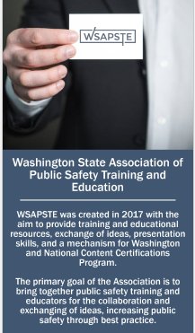

The newly formed ***Washington State Association of Public Safety Officers and Educators*** (WSAPSOE) held its first Board Meeting at Big Bend Community College in Moses Lake in July during CJ Programs meeting. The goal of the Association is to bring together public safety professionals and educators to collaborate, exchange ideas and increase public safety through sharing best practices. The Association will be addressing the development of State and National Content Certifications Programs. Dr. Ryann Leonard the Coordinator and faculty for the Criminal Justice Program at Big Bend and Linda Crerar, Director for HSEM Center of Excellence, we invited to join the Board. The Associations’ kick off conference will be held November 7th and 8th at the Spokane Sheriff’s Office Training Center in conjunction with the CJ Programs Working Group meeting. The Association is working on establishing their website and developing their membership outreach campaign. For additional information contact Steve Lettic at [slettic@gmail.com](mailto:slettic@gmail.com).

Announcing a New Publication

NEWS PROVIDED BY HSEM Center of Excellence

On August 9, 2017, the Center sent out a news release informing our colleges and other constituents about our new publication 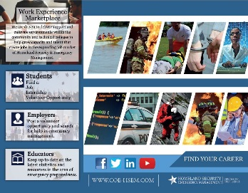***FIND YOUR CAREER*** brochure. The brochure was developed by our publications design staff with the help of our website and publication’s staff and volunteers. The brochure showcases our six major all-hazard emergency management pathways with eye catching visuals and a description of each career pathway field. This fields include our Criminal Justice and Security, Cybersecurity, Emergency Medical and Health, Fire Services, Homeland Security and Occupational Health and Safety. Amy Hatfield, Dean of Workforce Development, at Olympic College commented *“Thanks for sending your report. Wow – you guys have accomplished a lot. You should be really proud!* Is there any chance we could possibly get a brochure for the partner schools that shows the pathway to Pierce’s program specifically for the certificate and degree we offer.”

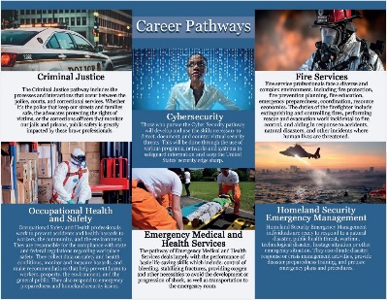The brochure describes our [*WORK EXPERIENCE MARKET PLACE*](http://wp.pierce.ctc.edu/blog/hsemcoe/job-outlook/) which provides information for students, employers and educators on internships, jobs and other opportunities in these expanding career fields. [*HSEM Career Pathway Programs*](http://wp.pierce.ctc.edu/blog/hsemcoe/pathways-programs/) Resource Guide is available to download or search the website to find programs in our Colleges statewide. Deborah Welsh, Director of Program Development & Worker Retaining in Bremerton said, “*I ALWAYS find your website helpful!  I will check it out—thanks much!”*

The newly updated Resource Guide will be available online later this year. Our new Guide will have additional information and references to assist student, faculty, employers and our community members to find degree programs throughout the state in our career pathways.

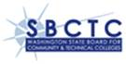**Annual Work Plan 2017-18 Approved by the State Board**

Every year the Center staff working with our Board and stakeholders reviews the Center’s current work and holds a strategic planning session to discuss and identify plan activities for the coming year. On August 16, the Center received it approval letter from Peter Guzman, Workforce Education Policy Associate at SBCTC. Danny Marshall who works with Peter provided a verbal comment to us regarding the good quality of our plan which needed no revisions.

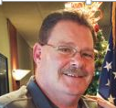**Welcome to our New Board Member Jim Maltby Lynden Transport**

We are pleased to welcome Jim Maltby, Corporate Director of Health, Safety, Security and Environment (HSSE) with Lynden Incorporated as a new member of our HSEM Center of Excellence and Pierce College HSEM Degree Program Advisory Committee.

Jim’s background includes 12 years of service in the Air Force as a Crash/Fire/Rescue (CFR) Specialist and Fire Inspector. In addition to his years as a firefighter, his background includes 20 years’ experience instructing hazardous materials emergency response, highway and railroad emergency response specialist and hazardous materials transportation. He h served in the Hazardous Materials Response Team, member of SERC Training Subcommittee and Chairman of the Trucking Association Safety Management Council in Alaska before coming to Washington as Lynden’s Corporate Director for HSSE. Center staff first met Jim when he served as a speaker and panelist at our 2016 Securing the Supplying Chain Forum and then again as a member of the Critical Infrastructure Interdependencies panel at this year’s PNWER Resilience Summit in Portland where he spoke about systems, frameworks and organizations that could be put in place to prepare for recovery operations in a Cascadia type event.

Jim is known for his “can do” attitude and like the company he works for “believes that problems can be solved in the hands of the right people, with the right tools and right experience.” Jim has experience hosting interns and is looking forward to being on the Board to share his knowledge, skills and experience in our six career pathway. He has worked in all six areas. He supports and wants to help us expand the work we are doing to assist our students gain valuable “work experience” through internships and other opportunities. You can welcome Jim at [malby@lynden.com](mailto:malby@lynden.com).

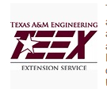**TEEX Training August 15-17 at Cascadia College**

The COE and Cascadia College hosted over 50 college/university executives and security, safety and emergency management professionals at the Emergency Management Preparedness and Planning course for Education Institution. This free 3 day training event was provided to the state by a DHS training grant. This is the second TEEX event the Center has brought to our CTC system this year. A similar training for Allied Health Professionals and organizations was hosted with the Allied Health COE at Yakima Valley College in the spring.

Shane Moore, Center’s Employer Engagement/Outreach staff and HSEM BAS student attended and he said, “This course explains how every person brings a unique set of skills and knowledge base to the table. Everyone has a role to play, they just need courses like this one to show them where they fit into the EM cycle, and how they can invaluable asset.” The recent update to this course has only improved its effectiveness as a teaching tool. Clearly explained technical EM knowledge, practical exercises based on real-world events, and a cadre of well-rounded instructors came together to provide perhaps some of the most effective and beneficial training available. He believes that everyone in attendance of this course, even seasoned EM professionals, took away valuable lessons to apply at their colleges and universities.

**Regional Updates from Center Outreach Staff**

**2017 WA-ACTE Summer Conference "Fostering Success"**

Anita Janus the Center’s eastern WA outreach specialist attended the ACTE summer conference in Spokane August 6-9.  The conference had several threads including

* Identifying and promoting effective Career Tech Ed educator and andragogy of student engagement.
* Identifying CTE curricula focused on students mastering technical skills in high demand occupations.
* Discovering available resources to implement effective career connected learning opportunities for CTE programs in K-12 leading up to community and technical colleges system.
* Sharing best practices for effective business and industry partnerships.

Anita met with Rachel McAloon, Outreach and Education Specialist, WA Department of Labor & Industries, Cecile Bamer, Employer Outreach Coordinator, COE: Construction and Kairie Pierce, Union Representative working with Labor & Industries.   They asked Anita for help connecting them to the colleges in Eastern WA relative to Tech Centers, Wenatchee Learns (Diana Haglund does a lot with employer engagement in our area) and also the Hispanic Orchard Employee Education Program (HOEEP) which is an agriculture-based certificate program directed at Hispanic orchard workers who have the potential to and interest in becoming managers of orchards.  Anita believes that there might be additional opportunities for apprenticeships for participants in that program.  It was a productive meeting and they will continue to collaborate.

**UPCOMING EVENTS**

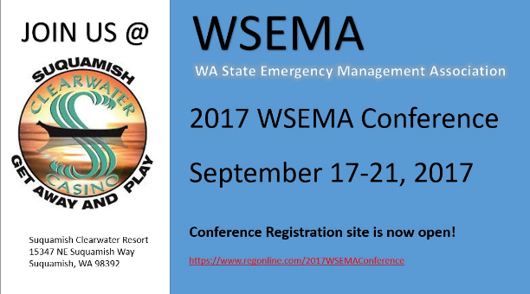

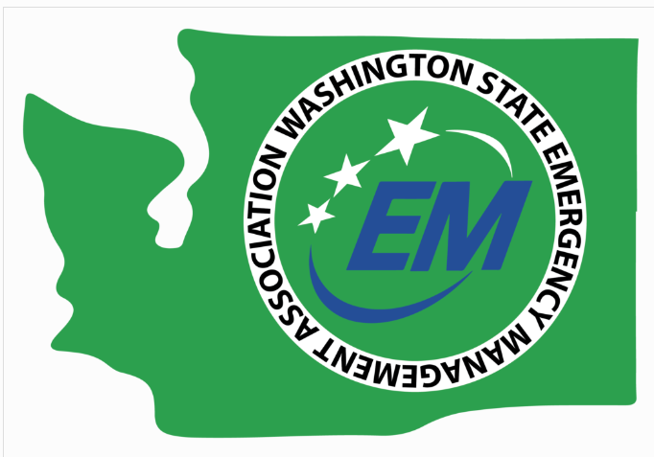

The Center will have an information booth at the upcoming WSEMA annual conference September 17-21. The Center and some of our Advisory Board Members will be presenting a panel discussion on Leadership in Emergency Management at the Conference.

**Women in Leadership Forum:**

**Raising the Bar! Women in Technology and Building Relationships**

**When:** TBD (either October 25th or November 1st)   
Location: TBA (Lake Washington Technical College)   
Hosts:  Center of Excellence for Homeland Security-Emergency Management   
9:00 a.m. – 3:30 p.m.

**AUDIENCE:** students, AmeriCorps, program coordinators/faculty, employers

**WHAT:** A follow-up to the 2016 Women in Leadership Forum. The theme of this year’s Forum will be on Women in Technology and will coincide with October’s Cyber-Security month. Technology is constantly changing and more women are entering into the field.  The Forum will also debut the Center’s online mentoring program called Leadership Circles. The Leadership Circles will provide a space for women looking for mentors. Leadership Circles will offer secure conversations for mentors and mentees, real-time chat, stand-alone-modules for online mentoring for mentors and mentees to work through, and will even help to match mentors with the right mentees.

**PURPOSE/GOAL:** The purpose/goal of the Forum is to help women identify what are their strengths are as leaders, where they want to go in terms of education and career, help them find/follow their dreams and goals, along with them discovering what kind of leader/leaner they are. It is important for the attendees to walk away with a sense of understanding the significance of creating strong and dynamic relationships/partnerships/collaborations with both women and men. This year’s Forum will help to build and inspire leaders in the technology field.

**2017 COE Schedule of Events**

September WSEMA Conference – Suquamish, WA – Sept. 18-21

September 28 Energy and Technology Transportation Infrastructure Workshop, Portland, Sponsored by Center for Disaster Resilience

October Advisory Board Meeting – Location TBA; 12:00 p.m. to 4:00 p.m.

Oct or Nov Women in Leadership Forum – Location TBD; 9:00 a.m. to 3:30 p.m.