***2018-19 WORK PLAN ACTIVITIES TO ADDRESS FOCUS AREAS OF INDUSTRY SECTOR***

***STRATEGY, EDUCATION, INNOVATION, EFFICIENCY & SUPPLY AND DEMAND***

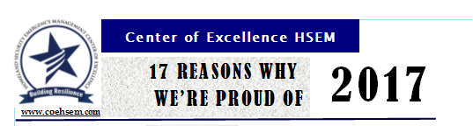

Center produced and distributed its annual report titled ***“17 Reasons Why We’re Proud of 2017.”*** This two page document highlights the Center’s accomplishments. The reports has been distributed to the Centers stakeholders and constituents, Board Members, partners and Workforce Programs and posted on our website. Response from readers is very positive both about the format and the ongoing work of the Center to support quality and effective programs and curriculum in our community college that benefit our state’s students and employers. The report is available on our website ["17 Reasons Why We're Proud of 2017"](http://www.coehsem.com/wp-content/uploads/2018/01/2017ReasonsWhyWereProud.pdf).

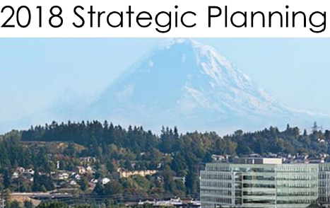The Center held its ***Strategic Planning*** session with the Advisory Board, Senior Fellows, staff, students and community members and employers on January 30. Chris Johnson the Board Chair hosted the Planning Retreat at Valley Medical Center. Center staff produced a planning packet that provided participants with the COE history and authority, mission and goals, partners and stakeholders and information about “envisioning the future” through strategic discussions. The Center completed a pre-planning survey which provided additional feedback from Board Members and others who were unable to participate in person. The Retreat was facilitated by Mark Todd who was trained through the Gates Foundation to assist public and non-profit organization in developing a strategic framework through highly effective interactive discussions and prioritization processes.

The session had three goal areas; 1) Resources:  Increase/diversify revenue sources to support the Center; 2) Program:  Support the building of effective HSEM programs statewide, and 3) Infrastructure:  Create a consistent statewide COE HSEM brand and operations platform that communicates and markets our program services and resources using outreach and education activities that may utilize our website, social media, webinars, and other multi-media opportunities to highlight the career field, our employers, our state’s programs and Center/state accomplishments. The summary report will be utilized to develop more specific objectives and actions items for the Center’s next three year plan which will be available at the end of February on line and shared with all participants and stakeholders.

**Washington Association of Public Safety Trainers and Educators (WSAPSTE) Conference**

[CONFERENCE REGISTRATION
 

HOTEL INFORMATION
](https://www.eventbrite.com/e/wa-state-association-of-public-safety-trainers-educators-conference-tickets-41768943033?aff=es2)On January 14, the Center announced the established WSAPSTE and its first annual statewide conference ***“Defensible Training and Education – Developing Keys for Success”.*** The conference will be held February 26 to 27, in Spokane at the Spokane Sheriff’s Office Training Center. The purpose of the Association is to provide training and education resources and the opportunity for public safety trainers and educators to come together in a forum that allows for collaboration and increases our public safety through best practices curriculum.

Three (3) of the Center’s Board Members, Bill Overby, Skagit Valley College, and Drs. Ryann Leonard, Big Bend Community College and Dr. Steve Lettic, Highline College provided the leadership for the formation of the Association and they have also lead our Center’s effort to work with our CTC Criminal Justice Program Coordinators to review, analyze and recommend a core set of CJ courses that will provide a statewide standard to ensure all CJ Programs are graduating career-ready students. Our CTC CJ Program Coordinators and faculty will hold their quarterly Work Group meeting during the Forum. Other professionals from our various public safety fields including telecommunications, emergency management, and criminal justice/corrections, military and private security will be attending. Membership is open to anyone involved in public safety training and education.  Contact the Association for information or assistance with registration at [info@wsapste.com](mailto:info@wsapste.com) and find them on Facebook at <https://www.facebook.com/WSAPSTE/>.

**Establishing Apprenticeships in the All Hazard Emergency Management Field**

For the past year the Center has been working with the State Board, RAISE Grant Team Members, Pierce College, State Labor and Industries, and Labor Council staff to identify apprenticeship opportunities in the all hazard emergency management career field.  The Center is now a member of the WA State Apprenticeship Coordination Association (WSATC) attend the quarter WSATC meeting and announced that the Independent Insurance Agents & Brokers of Washington (IIABW) had agreed to pursue a registered apprenticeship program in December after working with the Center and Workforce Education staff throughout that last half of 2017. The IIABW will be submitting a proposal for approval at the spring meeting of the Washington State Apprenticeship & Training Council.

The Center is supporting the Apprenticeship and Employers Forum which will be held on February 13, at South Seattle College’s Georgetown Campus and will bring employers including the IIABW to share their views on how the Washington State Apprenticeship system can better support employers interested in Apprenticeships.   Center staff assisted in developing sponsorship tools and staff will attend the event to help developed tools for those assisting employers including videos.

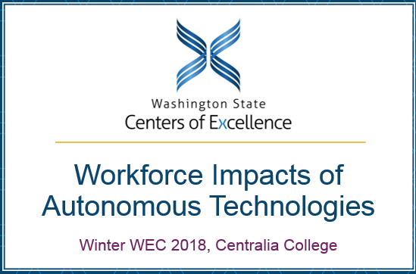**WEC Presentation-Workforce Impacts of Autonomous Technologies**

The Maritime, Global Trade/Supply Chain and HSEM Centers of Excellence presented at the Winter WEC meeting on the impacts of autonomous technology will have on our state’s workforce. The presentation provided an overview on how entry level employment will change and what critical IT skills will be required for employment. The presentation covered regulatory changes that upskilling our current workforce driving more professional development training through our Continuing Education Programs. The presentation was well received.

.



**Registration:** [**Register Now**](http://tiny.cc/a0vqqy)

The Centers of Global Trade/Supply Chain and HSEM announced the “Save-the-Date” for their 2018 Securing the Supply Chain Forum: The Internet of Things to be held April 26, at Highline College. This will be the 4th in the Centers series of Forums focused on the security issues related to trade and the supply chain. Industry, labor and educators a preparing for an avalanche of new products and services typing together assets, information, data and “things”. This will affect whole industries, society, culture, and the supply chain. The Forum gives educators and practitioners the opportunity to learn from experts in the fields and provides opportunities for participants to learn what changes will be critical to educate and graduate future graduates to work in the supply chain industry.

**Up Coming Events**

**Pacific NW Economic Region will hold its** 2018 Emergency Managers and Business Continuity Professionals Reception, February 13th [**Registration**](http://events.constantcontact.com/register/event?llr=mt6y4xbab&oeidk=a07ef0v4ii4b5520cbc). As emergency managers and business continuity professionals from the public, private, non-profit sectors, recognize the importance of having relationships in place with a wide variety of people and organizations before disaster hits.  Please join the CRDR, Snohomish County Emergency Management, the Northwest Healthcare Response Network, Berk Consulting, and the City of Seattle Office of Emergency Management for a networking reception on **Tuesday, February 13th at Seattle City Hall.**This will be a great opportunity to connect with the CRDR and other public and private sector professionals. Light refreshments will be provided.

**2018 COE Schedule of Events**

February 13 Apprenticeship and Employer Forum – South Seattle Georgetown Campus

February 27 High School Transition Tour Olympic College Bremerton College – Center Participating

February 26-27 CJ Program Managers/Directors Quarterly Meeting & CJ Assn. Conference, Spokane, WA