***STRATEGY, EDUCATION, INNOVATION, EFFICIENCY & SUPPLY AND DEMAND***

**Center of Excellence – Homeland Security Emergency Management**

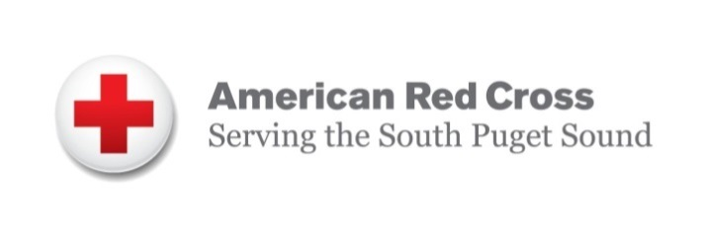

South Sound Chapter’s Executive Director Bonnie Bush reached out to Pierce College and the Center and asked if someone from our organizations would be interested in serving on their Advisory Board. After meeting and talking with Bonnie both Linda Crerar, COE Director, and Jo Ann Baria agreed that Linda would serve as the Advisory Board Member for Pierce District and the Center and Jo Ann Baria the Vice President for Workforce would support and assist the Center in the work of our South Sound Red Cross. Linda will attend her first Board meeting on Wednesday, April 25. The FY 18 areas of focus for South Sound Red Cross is community outreach and engagement including blood drives and their Home Fire Campaign, helping Red Cross tell its story and open doors to organizations and individuals, and targeted volunteer recruitment. Linda has a strong commitment to supporting and expanding voluntary action in our state. Linda served as the first Director for the state’s Voluntary Action Center in 1982 and continue today to involve many volunteers in her organization and initiatives.

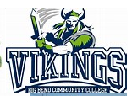

**Centers of Excellence are hosted on campuses around the state** but their work with their industry sectors and colleges requires Centers to work statewide with our 34 SBCTC colleges. In 2016 the HSEM Center regionalized its staffing and service delivery model which allowed us to provide more face-to-face personal contact with our colleges which allows us to build strong relationships and understand the needs of our industries and college customers. The week of April 9, our Center Director, Program Manager and Eastern WA Outreach and Education Coordinator Dr. Ryann Leonard spent three days meeting with Big Bend, Columbia Basin and Walla Walla senior executive staff, program directors and faculty, students and industry. While meeting with Ryann at Big Bend we were able to learn more about their UAV training program which had just received DHS Certification and was hosting the Drone/Droids Symposium and completed our education outreach and employer engagement plans for the remainder of the year.

During our visit at Columbia Basin were learned about their OSHA 10 Safety Certification course which is of interest to the Occupation Safety and Health apprenticeship project at Edmonds College and our efforts to help expand the OSH training statewide. We also met with Tim Harris their Criminal Justice Program Manager who is one of our CJ Programs statewide workgroup addressing and building a core CJ curriculum and discussed opportunities to continue the development of additional training and certifications for their CBC programs. Arriving at Walla Walla College we were hosted by Lindsey Williams the Director for their Agricultural Center of Excellence. During meetings with their President, Dr. Derek Brandes, and Tim Toons the Assistant Dean working on the development of their new Criminal Justice Program, we heard how supportive they are of the work that has been done on the CJ Core Curriculum by the statewide CJ Work Group. They also talked about their interest in other opportunities to collaborate with our all hazard emergency managements programs around the state. We agreed to organize a Forum in the fall of this year at Walla Walla in conjunction with the Ag COE that will focus on food protection to secure our agriculture economy and take initial steps to develop a Food Defense Certification. The college is also very interested in looking at how we can more effectively design interdisciplinary programs in rural communities pulling together wild land fire, OSH, law enforcement, and emergency manage, security/cybersecurity and UAVs. We will be meeting with Oregon’s Higher Education Coordinating Commission later this spring to discuss opportunities for our rural communities and colleges that we can all support.

***HSEM Professionals and Academics***

The Center was a member of the planning committee that worked with Wendy Walsh, Higher Education Program Manager for FEMA’s National Raining & Education Division, to invite our state’s community practitioners and academics to attend the ***regional networking event Tuesday, April 3, 2018***, at the FEMA Region X office in Bothell, WA and two hub locations in Meridian, Idaho and Portland, Oregon.

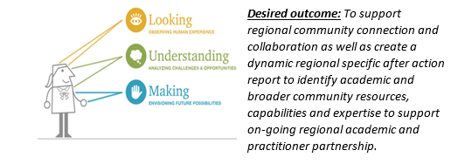

The purpose of the meeting was to build awareness, capture success practices of collaboration with faculty, students and researchers working with emergency management practitioners.   The event “provided an opportunity for people to discuss challenges and possible untapped opportunities for future coordination” said Wendy.  “Our desired outcome is to support sustained regional community connections, encourage collaboration and create a regional snapshot comment to facilitate matching capabilities and expertise to needs.”

The HSEM Center of Excellence [www.coehsem.com](http://www.coehsem.com) presented on the Community and Technical College all hazard emergency management programs available in Washington and the University of Washington’s will discuss their online Master of Infrastructure Planning and Management program which is Part of the Department of Urban Design & Planning <https://www.infrastructure-management.uw.edu/> and focus on risk assessment, HAZUS and storytelling.  The Center invited all of the All Hazard Emergency Management SBCTC Program Managers and Directors, faculty and staff to attend onsite at the Region X office in Bothell or participate virtually. We expect several of our programs to participate around the state. The Center recommended and Shane Moore, one or our Center’s Employer Engagement/Outreach Coordinator and soon to be one of the first BAS HSEM BAS program graduates this June was selected to be the paid Consultant Reporter for the Regional event. Shane will draft and publish the Region X meeting summary report which will be published on the FEMA Higher Education website.

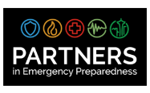

[**Partners in Emergency Preparedness**](https://www.cm.wsu.edu/ehome/index.php?eventid=25597&)

The Center partnered with several colleges and programs to host an information booth at the Partners in Emergency Preparedness Conference which is organized by the Washington State University on 18th April to the 19th April 2018 at the Greater Tacoma Convention Center. The conference covered areas including cutting-edge information on subjects such as business continuity planning, school safety, public health preparedness, homeland security, and public information.  Scott Preston, faculty with the 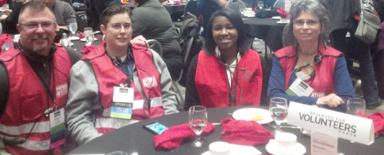HSEM Degree Program hosted at Pierce College and offered statewide at Peninsula, Olympic, Big Bend, Highline, Cascadia, Edmonds, and Skagit provided the Continuity of Operations training program for the session and also supported five (5) of his winter quarter students taking his COOP course to serve as volunteer staff for the Conference. The Center was able to assist them and others interested in furthering their careers in all hazard emergency management and Darren Linker the Program Manager for the state’s Occupational Health and Safety Degree met with both employers and students about apprenticeship and internship opportunities.

We had so many people drop by the Center’s booth that we had to have extra chairs brought out in order to accommodate them. People learned more about the variety of degree programs offered by our Community and Technical Colleges in Washington including programs that offer training in operations of unmanned aerial vehicles and learn about the new Center of Excellence for Unmanned Aerial Vehicles that is housed with the Center for Aerospace. Next year’s event will take place in Lynnwood Washington and the Center will serve as one of their sponsoring organizations.

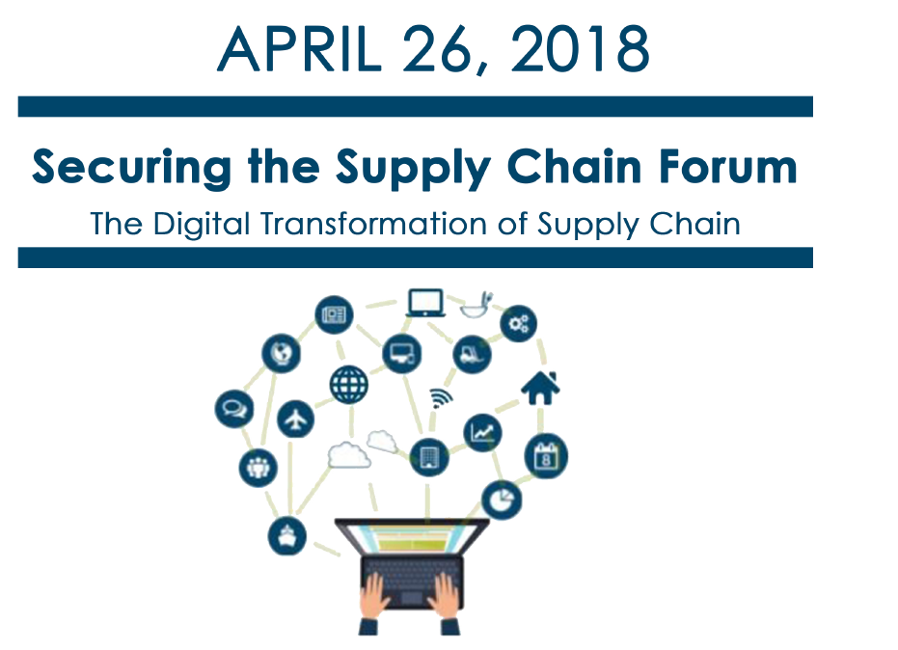***Center Collaborates with Global Trade/Supply Chain Management COE for HSEM/Supply Chain Professionals, Academics and Students***

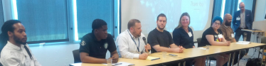

The Centers reached out to our state’s higher education faculty and administration to help us to **recruit students** to attend our 4th Annual Securing the Supply Chain Forum on ***on Thursday, April 26, 2018.***

This year’s Forum addressed **“The Digital Transformation of the Supply Chain”.** Seven students from our colleges’ Criminal Justice, Homeland Security-Emergency Management, Logistics and Cybersecurity Programs participated on the “Student Panel” in the afternoon with Terry Dell one of our featured keynote speakers with The Movement Company.  Students shared their recommendation with our educators on how they are going to manage the change occurring due to technology.

Two members of the panel, Alana Dacosta and JD Jenkins from Highline College, we selected to receive a scholarship from Aronson Security to attend the 2019 “The Great Conversation” Summit which focuses on public safety, security and technology. Tommi Robison, Director for Strategic Development for Aronson Security and Advisory Board Member for HSEM Center provided the scholarships worth over $1700. UW’s Global Business Program also supported the Forum with a grant.

Our panel policy experts shared information about technologies and regulations.  Companies need to keep pace with its supply chain processes and the progression of technology, and for education and training programs to evolve curriculum has to keep pace with these changes. Our faculty panel provided feedback at the end of the day on the information they will incorporate into their future curriculum.

The Forum Report and video will be available on the Centers’ websites at the end of May. [www.coehsem.com](http://www.coehsem.com).

**The Center has established a Design Team** which meets bi-monthly and is focused on expanding our social media exposure and content. The Team agreed that the Center is a clearing house, one-stop-shop, and a promoter of learning/growing opportunities. It also offers human interaction and builds relationships where we can be available for students and provide resources for the HSEM programs/opportunities.

The Team focused its discussions on the need to communicate in a variety of media including social media with the Center’s audience which is our students, faculty and employers. In order to expand our social media presence, we will implement strategies discussed including adding new marketing material to colleges. The team identified several strategies for evaluating outreach to our student audience. These approaches will be evaluated and if successful, will be more broadly implemented. Kellie, Justin and I also discussed the possibility of putting an ad in The Pioneer (Pierce College’s student magazine) to help increase student awareness. We will look at our current website and discuss changes to implement to help with consistency.

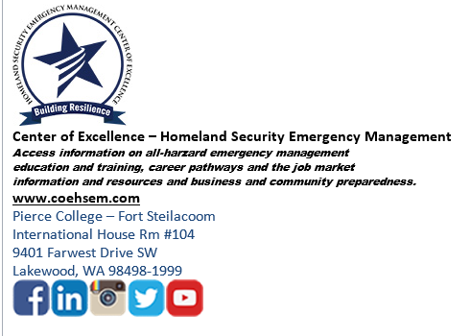The Team also agreed upon a new “signature block” with all of our social media accounts visually highlighted for our staff to use. Please check us out on our social media sites and Blog. [www.coehsem.com](http://www.coehsem.com)

***Winter Quarter Web Statistics***

Webmaster reported:

**Trends:**

The website statistics are up 30% winter quarter largely due to search engine exposure (moving website to Go Daddy from Pierce website) for new pages and postings. The search referrals percentage across the website increased almost two-fold, which means more people are finding the website with search engines, including Google, Bing, and Yahoo. Some of our most popular website referrals are from the Google jobs page and the individual job postings are seeing more exposure in regular web searches. Two of the most popular pages this last quarter were the professional affiliations page and the emergency management cycle page. The average amount of time spent on the professional affiliations page was 9 minutes. People are spending a good amount of time on our hot topics and our services pages this quarter.

Web Google Stats Link:

[**http://www.coehsem.com/wp-content/uploads/2018/04/jan-march-analytics.pdf**](http://www.coehsem.com/wp-content/uploads/2018/04/jan-march-analytics.pdf)

[**http://www.coehsem.com/our-services/**](http://www.coehsem.com/our-services/)

**2018 COE Schedule of Events**

April 28-29 Future of Women in EMS/Fire Academy

May 21 Center’s Advisory Board Meeting