Linda Crerar, Director
Center of Excellence Homeland Security/Emergency Management

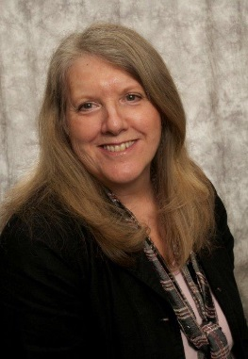
Linda is an experienced business and government executive with more than 40 years of service in the public and private sectors. Her focus for the past 12 years has been on developing statewide strategies that build resilience in organizations and communities to prepare for and recover from emergencies and disasters. As the legislative coordinator and policy staff for Washington’s Military Department Emergency Management Division, Linda facilitated a statewide workgroup of emergency managers in the development of baseline performance measures and standards for state and local government agencies. After leaving the Military Department, Linda served as the Program Coordinator for the Pierce College’s online Homeland Security-Emergency Management (HSEM) AA Degree Program where she supported the expansion of the HSEM degree program making it available and accessible for students in colleges across the state. In 2012, she was appointed as the Director for the state’s Homeland Security Emergency Management Center of Excellence. As part of the Center’s role to support public safety, security and emergency management programs within the community and technical college system, she directed the research efforts that were used to establish the state’s first Bachelors of Applied Science (BAS) degree in HSEM. She has been a leader for many years in helping state and local governments address critical environmental and resource management issues. She co-lead a statewide initiative implementing the state’s Watershed Management approach which in 1998 became the Watershed Planning Act. She also co-led the development and implementation of the state’s agricultural strategy for the Governor’s Salmon Recovery Plan which was a voluntary negotiation process involving the agriculture industry, tribes, and multiple levels of government to address requirements of the Endangered Species Act for recovery of salmon. Linda continues to be an active member of state and national associations in the public safety and emergency management fields and severs on the Washington Information Networks 211 Board of Directors.

Linda has a Masters in Applied Behavioral Science (MA ABS) from Whitworth College in Spokane, WA and Bachelor of Arts from The Evergreen State College in Olympia, WA.

Contact information:
Linda Crerar
Pierce College
9401 Farwest Drive SW
Lakewood, WA 984981999
www.pierce.ctc.edu/homelandsecurity
(253) 912-3689
lcrerar@pierce.ctc.edu

