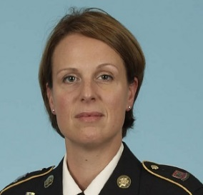
SFC Jacqueline Lavelanet graduated from Arizona State University Summa Cum Laude with a degree in French in 1998. After working briefly in the commercial real estate and accounting industries in the Phoenix area, she joined the Army after the events of 9/11 to work in the intelligence field. SFC Lavelanet studied Arabic and Farsi at the Defense Language Institute and deployed to Iraq and Afghanistan while on Active Duty. She joined the Washington National Guard in late 2010, where she currently works as an intelligence platoon sergeant and analyst.

Jacqueline S. Lavelanet
SFC, WAARNG

