STRATEGY, EDUCATION, INNOVATION, EFFICIENCY & SUPPLY AND DEMAND
Center of Excellence – Homeland Security Emergency Management
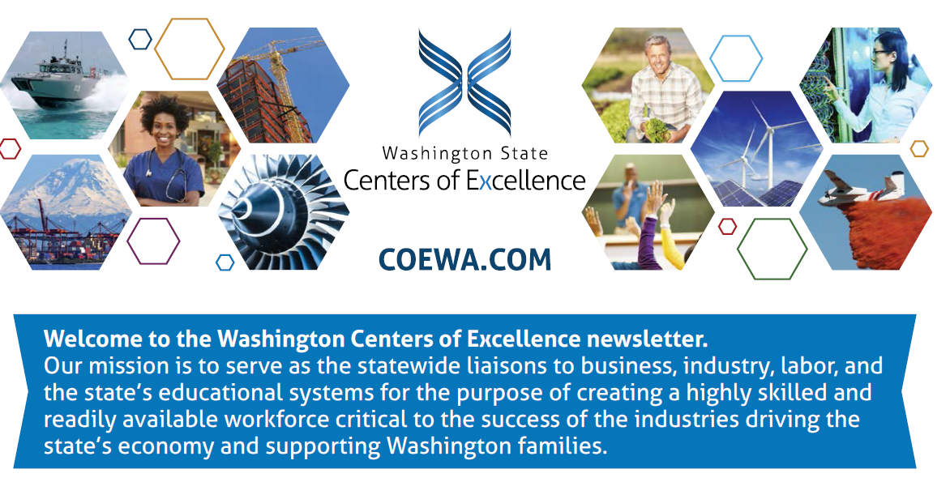
Activity Highlight for the Centers of Excellence Winter Quarter Newsletter
The WA State Association of Public Safety Trainers and Educators (WSAPSTE) first annual conference "Defensible Training and Education: Developing Keys for Success" was held at the Spokane County Sheriff's Training Center on February 26th and 27th. Dr. Steve Lettic, the Association’s President and Center Board Member welcomed over 30 attendees from across the state that included employers, CTC CJ program faculty and deans as well as private industry representatives. The HSEM Center of Excellence was a sponsor for this Conference and the SBCTC Criminal Justice Programs Working Group met during the conference to review and confirm the common course curriculum that had been developed over the past year.
The two day conference discussed the importance of training that is documented, cited, referenced and easily defensible. Learning outcomes focus on increasing participants’ knowledge of instructional design and occupational analysis while avoiding implicit bias. The conference also hosted a networking event and identified participants training needs for be addressed at future meetings.
Dr. Ryann Leonard, the Association’s Vice-President and Center Board Member, wrote up a report that highlighted the outcomes from the discussion about the CJ core course curriculum. What participants came up was a Master Course Outlines (we know these names vary by college) that would provide programs with the basic content that would be included in all five core courses. The idea behind the Master Course Outline is that it would be a general overview of what WOULD be covered in each of the content course; however, there would still be room for addition of material and academic freedom on textbook and format choice. Participants developed outlines that include a common course description, a common short set of core objectives, and a basic course content list. Five (5) core course Master Outlines were developed by compiling all syllabi submitted to the Canvas site (COE CJ) and then a subcommittee of CJ faculty wordsmith and found common themes during the February conference.
Center Collaborates with FEMA Region X to Host Regional Collaboration for HSEM Professionals and Academics
The Center was a member of the planning committee that worked with Wendy Walsh, Higher Education Program Manager for FEMA’s National Raining & Education Division, to invite our state’s community practitioners and academics to attend a regional networking event Tuesday, April 3, 2018, from 10:00AM to 2:30PM (PST) at the FEMA Region X office in Bothell, WA and two hub locations in Meridian, Idaho and Portland, Oregon.
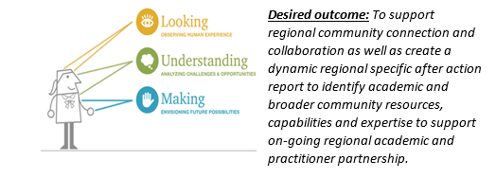
The purpose of the meeting is to build awareness, capture success practices of collaboration with faculty, students and researchers working with emergency management practitioners. The event is “intended to provide an opportunity for people to discuss challenges and possible untapped opportunities for future coordination” said Wendy. “Our desired outcome is to support sustained regional community connections, encourage collaboration and create a regional snapshot comment to facilitate matching capabilities and expertise to needs.”
The HSEM Center of Excellence www.coehsem.com will be presenting on the Community and Technical College all hazard emergency management programs available in Washington and the University of Washington’s will discuss their online Master of Infrastructure Planning and Management program which is Part of the Department of Urban Design & Planning https://www.infrastructure-management.uw.edu/ and focus on risk assessment, HAZUS and storytelling. The Center invited all of the All Hazard Emergency Management SBCTC Program Managers and Directors, faculty and staff to attend onsite at the Region X office in Bothell or participate virtually. We expect several of our programs to participate around the state. The Center recommended and Shane Moore, one or our Center’s Employer Engagement/Outreach Coordinator and soon to be one of the first BAS HSEM BAS program graduates this June was selected to be the paid Consultant Reporter for the Regional event. Shane will draft and publish the Region X meeting summary report which will be published on the FEMA Higher Education website.

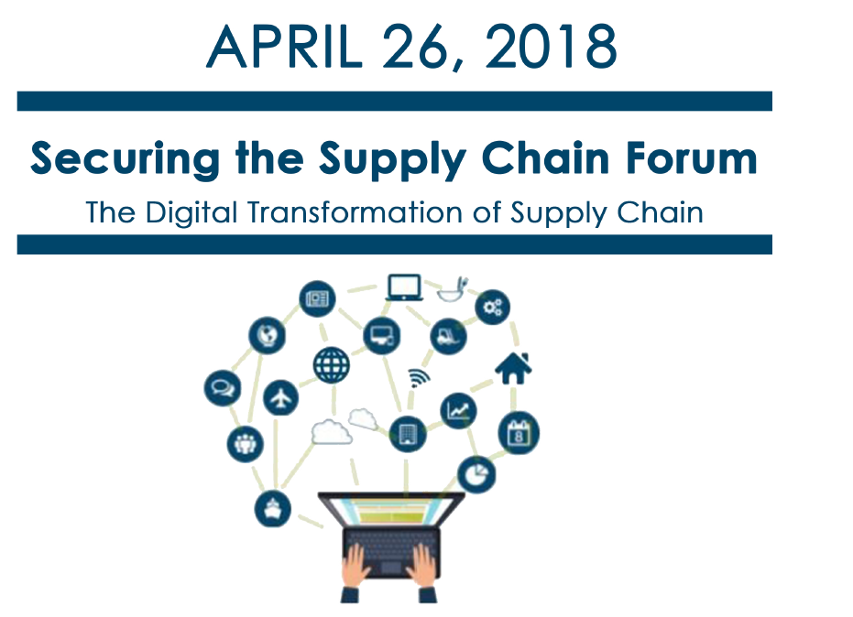
Center Collaborates with Global Trade/Supply Chain Management COE for HSEM/Supply Chain Professionals, Academics and Students
The Centers are reaching out to our state’s higher education faculty and administration to help us to recruit students to attend our 4th Annual Securing the Supply Chain Forum on on Thursday, April 26, 2018. This year’s Forum will be addressing “The Digital Transformation of the Supply Chain” We are looking for students who would like to participate on the “Student Panel” in the afternoon with Terry Dell one of our featured keynote speakers with The Movement Company”.
This year’s theme is “The Digital Transformation of the Supply Chain”. We will be discussing how the supply chain is being transformed by emerging technologies from industry and policy experts developing today’s technologies and regulations. We will address the need for companies to keep pace with its supply chain processes and the progression of technology, and for education and training programs to evolve curriculum to keep pace with these changes also. There is no charge to attend. Register HERE! Each year our number of student’s attendance has grown. Last year about 20% of our attendees were students from a variety of our degree programs around the state.
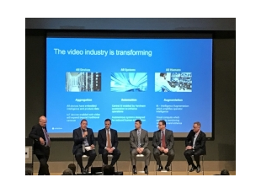
"The Great Conversation in Security"
Our Center Director was invited to attend this two day education forum March 5-6 in Seattle which focused on both the challenges and opportunities organizations face in risk, resilience, and the business value of security. The conference topics addressed security culture, intelligent communications, Deep Learning, AI and IA, insider threat management and threat response, risk planning and resilience and the risk on our education campuses. Kristina Anderson, a survivor of the Virginia Tech shooting provided the closing key note addressing the job that security professionals are tasks with in protecting people lives and their property and possessions. The Center will be researching opportunities for establishing Certified Protection Professionals including Certified Food Defense Coordinators that would complement our current statewide Criminal Justice and Risk Management Programs.

Welcome to a New Advisory Board Member
Tommi Robison, Director of Strategic Development for Aronson Security (ASG) and a longtime supporter of Centers of Excellence here in Washington, has joined our Advisory Board. ASG is an Information Management Technology Company focused on Risk, Resilience and Physical Security solutions. Tommi has many years of experience working in and with the public, private and private nonprofit sectors a variety of career fields including healthcare, food security/safety and security/risk management. She has supported our Securing the Supply Chain annual forums since their inception 4 year ago and is helping the Center in its efforts to develop women in leadership through her stewardship and leadership modeling.
Tommi serves as the co-chair on the King County Critical Infrastructure working group with Curry Mayer another of the Center’s Board Members. She also is a member of ASIS International serving as a committee chair. Tommi has received many awards including the Seattle Mayor’s End Hunger Award for Community Leadership. Tommi has 20 years of experience in business process, facility design and security and is a graduate of Antioch University in Seattle’s BA in Sustainable Design (Whole System Change). We are excited about having her join our Board as we move into the “next generation security integrators” where technology will dramatically change the way we do security and address public safety issues.

The Center’s Strategic Framework Progress for 2018
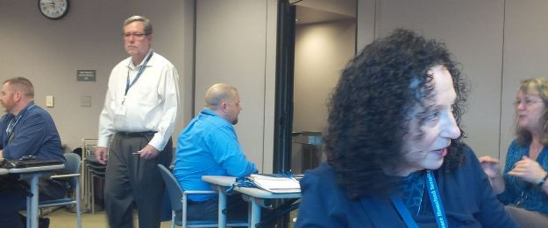
The Center held its Strategic Planning session with the Board and staff on January 30. The session had three goal areas that included discussion on diversification of Center resources, building effective career pathway programs statewide and creating a consistent statewide COE HSEM brand and operations platform that communicates and markets all of our state’s public safety, security and emergency management programs and resources. The group completed a “grounding exercise” addressing and revalidating the Center’s mission, vision, goals and value and spent time envisioning the future. Meeting summary has been completed and will is available on our website. The Summary will be utilized by the Center’s Board at their May 21 meeting to complete a 3-5 year action plan that will address the three (3) Retreat goals. Reports and summaries will be available on the Centers website in April.

Center Advisory Board Member Presents at WSAPSTE Conference on Terrorism Prevention and Response
Dan Guerrero, Board Member and Senior Fellow with the Center was asked by WSAPSTE to present at their first Association meeting on “The Evolution of US Government’s Efforts to Combat Terrorism, & the Call to Adapt Law Enforcement Education to meet 21st Century Needs.” Dan has also assisted Highline and Tacoma College reviewing their emergency/disaster response plans and working with King County on FEMA "complex, coordinated terrorist attack" project.
Career Pathway Presentations Olympic Region

Shane Moore, Centers Employer Engagement/Outreach Coordinator, delivered 3 one-hour presentations on HSEM at Olympic College's Shelton campus on March 14th, 20th, and 26th. These presentations are focused on sharing with students what homeland security-emergency management is and what its career pathways are to answer questions and support program enrollment. Shane has published with the help our Design staff, Jasmine May, a power point that can be used by staff and Board Members at colleges and other presentation. Amy Hatfield, Dean at Olympic College, thanked Shane “for stepping up and continuing on this... you are the perfect liaison for the new direction in our HSEM program.” Shane can be contacted at SMoore@pierce.ctc.edu for those interested in the presentation.

March 22, 2018 – News Bulletin

The “Future of Women in EMS/Fire Academy” is hosting an event on April 28-29, 2018 from 9am to 5pm at the Northshore Fire Department. This two-day event said Kate Hansen, “is aimed at women 20 to 25 who are interested in exploring EMS and Fire as a career path.” This will be a full weekend that includes first aid and CPR training, demonstrations, discussion panels and hands-on interactions and training. The information flyer is attached and Kate’s contact information is below.

Fire service professionals face a diverse and complex environment. Community and Technical College Fire Service Programs and information are available on the Center of Excellence HSEM’s website. Programs include Fire Service, Fire Protection Engineering Technology, Fire Science AA degree and Aircraft Rescue Fire Fighter and Wildland Firefighter Certifications, Fire Command and Administration AA and Fire and Emergency Services Technology AA. A program in the Fire Science Pathway will teach students to respond to emergencies and save lives, identify, stabilize and mitigate emergency situations, reduce loss of property and improve public safety.

Careers in Fire Service are growing along with the opportunities. Please take advantage of this opportunity to attend the Academy April 28-29 in Kenmore.

Winter Quarter Web Statistics

The Center has established a Design Team which meet bi-monthly and is focused on expanding our social media exposure and content.

Webmaster reported:

Trends:
The website statistics are up 30% winter quarter largely due to search engine exposure (moving website to Go Daddy from Pierce website) for new pages and postings. The search referrals percentage across the website increased almost two-fold, which means more people are finding the website with search engines, including Google, Bing, and Yahoo. Some of our most popular website referrals are from the Google jobs page and the individual job postings are seeing more exposure in regular web searches. Two of the most popular pages this last quarter were the professional affiliations page and the emergency management cycle page. The average amount of time spent on the professional affiliations page was 9 minutes. People are spending a good amount of time on our hot topics and our services pages this quarter.

Web Google Stats Link:

http://www.coehsem.com/wp-content/uploads/2018/04/jan-march-analytics.pdf
http://www.coehsem.com/our-services/

2018 COE Schedule of Events

April 17-19 Partners in Preparedness Tacoma Conference Center
April 26 Securing the Supply Chain Forum – Highline College
April 28-29 Future of Women in EMS/Fire Academy
May 21 Center’s Advisory Board Meeting

