2017-2018 WORK PLAN ACTIVITIES TO ADDRESS FOCUS AREAS OF INDUSTRY SECTOR
STRATEGY, EDUCATION, INNOVATION, EFFICIENCY & SUPPLY AND DEMAND
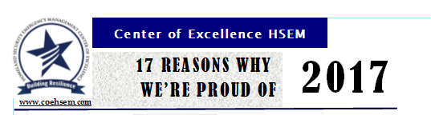
Center produced and distributed its annual report titled “17 Reasons Why We’re Proud of 2017.” The two page document highlighted the Center’s accomplishments. The reports was distributed to the Centers stakeholders and constituents, Board Members, partners and Workforce Programs and posted on our website. Response from readers was very positive both about the format and the ongoing work of the Center to support quality and effective programs and curriculum in our community college that benefit our state employers. The report is available on our website "17 Reasons Why We're Proud of 2017".
The Center’s Strategic Framework for 2018
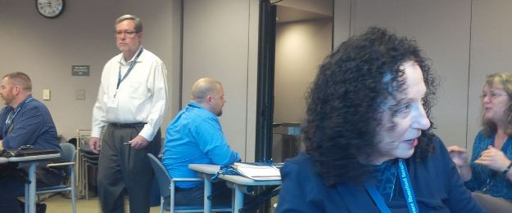
The Center held its Strategic Planning session with the Board and staff on January 30. Chris Johnson, the Board Chair, hosted the event at Valley Medical Center. Mark Todd one of the Center’s Senior Fellows served as the facilitator. Mark works nationally with organizations on strategic alignment and identification of success strategies. The session had three goal areas that included discussion on diversification of Center resources, building effective career pathway programs statewide and creating a consistent statewide COE HSEM brand and operations platform that communicates and markets all of our state’s public safety, security and emergency management programs and resources. The group completed a “grounding exercise” addressing and revalidating the Center’s mission, vision, goals and value and spent time envisioning the future. Meeting summary which included all of the discussion captured in the discussion groups has been drafted and will be utilized by the Board to complete a 3-5 year action plan that will address the three (3) Retreat goals. Reports and summaries will be available on the Centers website in March.
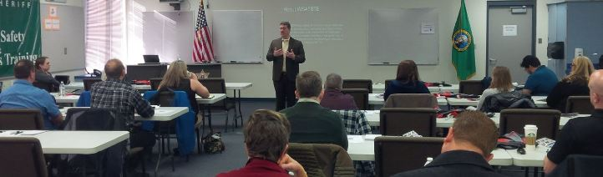

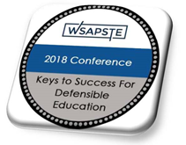

February 26-27 Washington’s Public Safety Trainers and Educator (WSAPSTE) held their first annual conference in Spokane. Over 35 trainers and educators attended. The Conference theme “Defensible Training and Education – Developing Keys for Success” provided participants the opportunity increase their knowledge of instructional systems design and occupational analysis while avoiding implicit bias. Individual breakout sessions provided an opportunity to network and learn with and from other professionals in related fields.
Steve Lettic, Association President and Center of Excellence Board Member, welcomed participants and introduced organizers and presenters that an included two Center Board Members Dr. Ryann Leonard, Vice-President of the Association and Big Bend CJ Program Coordinator and Dan Guerrero FBI (retired) consultant and terrorism/security expert was the opening keynote speaker. Dan’s comments focused on terrorism prevention and response. The Associations next conference will be on the west side of the state in October. The Center will produce a Conference summary that will be available on the website.
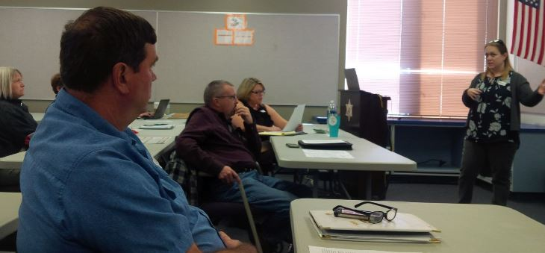
Outcome Development for Core Courses in Criminal Justice Programs (Facilitated Discussion) – Criminal Justice Faculty
Criminal Justice faculty in the State of Washington realized the need for curriculum that can produce skills our students need for employment. That curriculum needs to have objective standards that are measurable and observable. During the WSAPSTE Conference faculty and deans from our state’s CJ programs met to work with Dr. Ryann Leonard and Tim Harris (CJ Program Faculty/Coordinator at Columbia Basin College) to review the submitted curriculum syllabi and a summary of the most common topics covered in the suggested “core” set of classes. Faculty and deans spent two days reviewing and refining Master Course Outlines that will provide programs with a basic content course descriptions. The group completed a draft of core objectives and basic course content. This work will be shared with all CJ program staff and deans statewide and a follow-up meeting will be held mid-year. Participants included Central WA University staff and a discussions included developing a statewide articulation agreement for all college CJ program graduates. A summary of the meeting and recommendations will be published.

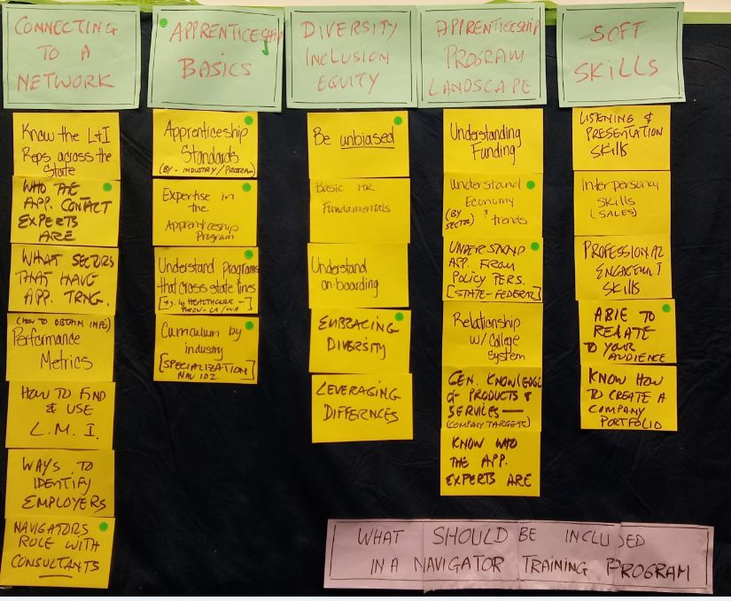
Establishing Apprenticeships: Employer Engagement Event

For the past year the Center has been working with the State Board, RAISE Grant Team Members, Pierce College, State Labor and Industries, and Labor Council staff to identify apprenticeship opportunities in the all hazard emergency management career field. The Center is now a member of the WA State Apprenticeship Coordination Association (WSATC).

The Center staff participated in an Employer Engagement event held on February 13, 2018 at South Seattle College’s, Georgetown Campus. The RAISE team solicited employers to present their views on how the Washington State Apprenticeship system can be of the most use to them. This event listened to employers and will utilize their advice and recommendations to improve outreach about apprenticeship in our state. The Center worked with the RAISE Grant Team Members to recruit the IIABW (Insurance Association) to attend. The event also explored apprenticeship models in less traditional settings like IT, manufacturing, healthcare and insurance. The purpose was to understand what adjustments are necessary to update the apprenticeship approach to meet employer needs in non-traditional work settings.

The organizers used a DACUM (Developing a Curriculum) process to gather information (see results above). The results include tools necessary to develop a training program for navigators, consultants, governmental agents and others to provide more effective support for employers interested in apprenticeship. “The employers attending represented an excellent variety of career fields,” said Shane Moore, Center’s Outreach/Employer Engagement Specialist. The day’s event consisted of determining what skills and knowledge the Apprenticeship Navigator should possess to be effective. A report will be completed and shared with all participants by the end of the month.

NEWS RELEASE – HSEM BAS Articulation Agreement Northeastern University
On February 15, Ron May, Dean of Health and Technology at Pierce College announced that the Pierce College Learning Council approved articulation agreement with Northeastern University for the BAS-HSEM student to go into their Master of Science in Security and Resilience Studies program was approved.
In the News Release, Wendy Freitag was acknowledged and thanked for her work with Northeastern University for the past two years that made this Articulation Agreement possible. Linda Crerar said, “Without Wendy’s hard work and building a strong connection with Northeastern University the offer would have never come from them to articulate the Pierce HSEM BAS students.” Wendy is also working with Pierce through the Center on completing an articulation agreement with the UW’s Master of Infrastructure Planning and Management degree.
Several Board Members and others who received the News Release send their congratulations including Lynda Zambrano, Executive Director of the National Tribal Emergency Management Council, who said, “I could not concur more! Wendy, you are amazing and we all appreciate your hard word.” Lynda has been a Center/HSEM Degree Advisory Board Member for six (6) years.
WEC Presentation-Workforce Impacts of Autonomous Technologies
The Maritime, Global Trade/Supply Chain and HSEM Centers of Excellence presented at the Winter WEC meeting on the impacts of autonomous technology will have on our state’s workforce. The presentation provided an overview on how entry level employment will change and what critical IT skills will be required for employment. The presentation covered regulatory changes that upskilling our current workforce driving more professional development training through our Continuing Education Programs. The presentation was well received.

Register Now The Centers of Global Trade/Supply Chain and HSEM announced the “Save-the-Date” for their 2018 Securing the Supply Chain Forum: The Internet of Things to be held April 26, at Highline College. This will be the 4th in the Centers series of Forums focused on the security issues related to trade and the supply chain. Industry, labor and educators a preparing for an avalanche of new products and services typing together assets, information, data and “things”. This will affect whole industries, society, culture, and the supply chain. The Forum gives educators and practitioners the opportunity to learn from experts in the fields and provides opportunities for participants to learn what changes will be critical to educate and graduate future graduates to work in the supply chain industry.
Center’s Participates in the Olympic College “What’s Next?” February 27 Event
Amy Hatfield, Dean at Olympic College thanked the Center and our outreach staff Shane Moore for his participation in their “What’s next?” tour. “Thanks for participating…students had a great time. Would you have some time to offer information sessions about the HSEM (all hazard emergency management career fields which include CJ, Fire, OSH, Cybersecurity, and Emergency Medical and Health Services) at our Shelton campus?” Shane thanked Amy and will be attending their event in Shelton. Shane said about his presentation, “most people do not know what the careers are in HSEM, but the name makes them curious enough to investigate. I found that once I began to explain in more students became interested in exploring the programs when they started their college education.” We hope that Olympic’s program enrollments will reflect Shane’s efforts.

2018 COE Schedule of Events

March 1 Center of Excellence Director’s Meeting Everett College
April 17-19 Partners in Preparedness Tacoma Conference Center
April 24 Securing the Supply Chain Forum – Highline College

