Emergency Management/Homeland Security Higher Education Regional Academic Collaborative Region X
Tuesday, April 3, 2018 -10:00 a.m. - 2:00 p.m. (PDT)
FEMA Region X – Bothell, WA; Concordia University- Portland, OR; Idaho State University- Meridian, ID
Specific Location & Virtual Participant Information will be provided prior to the event

Purpose: To build awareness, capture successful regional practices of collaboration with faculty, students and researchers working with emergency management practitioners as well as to identify untapped opportunities.
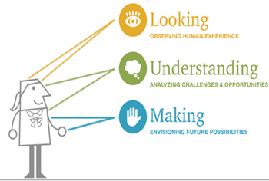
Desired outcome: To support regional community connection and collaboration as well as create a dynamic regional specific after action report to identify academic and broader community resources, capabilities and expertise to support on-going regional academic and practitioner partnership.
Agenda:
10:00- 10:30- Welcome & Introductions
10:30-12:00- Quick overview of FEMA Higher Education & UAPI programs & successful regional practices to be briefed in 5-7 mins with a couple minutes for questions:
- FEMA Region X & UAPI Program
*image from-http://www.bethkanter.org
- Risk assessment, HAZUS and storytelling- Dr. Bob Freitag
- Washington Center of Excellence model- Dr. Linda Crerar
- Emerging technology Integration for Emergency Management- Dr. Laurie Holien
- Virtual synchronistic class delivery- Dr. Michael Mikitish
- Alaska Efforts- Program Director, Dr. Cameron Carlson
- Placeholder- Private Sector?
- Placeholder- other?

12:00- 1:00- Working lunch: Small group dialogues to develop idea pathways to practice

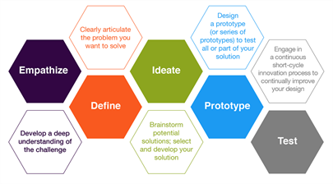
- Discuss presentations & other successful practices that could be shared and expanded?
- Who are the missing critical stakeholders in the region?
- Who cares about academic and practitioner collaboration?
- Are there challenges that these group face?
- What is possible in this collaboration?

1:00-1:45- Small group sharing with the whole group
http://citl.illinois.edu/paradigms/design-thinking

1:45-2:00- Next steps, wrap up & gratitude

